Current Weather Design Document

# Introduction

The purpose of this document is to outline the technical design of the current weather web application and provide an overview for the implementation

# Sequence Diagram:

This application is based on Spring MVC architecture.

Each request first comes to Front controller which is **WeatherController** in this case. This controller directs the request to a view which is **CurrentWeather**.**jsp** and also binds the model **WeatherBean** with the view. View displays the dropdown to the user, as soon as user selects a city, POST request is submitted asynchronously(using AJAX) which again goes to WeatherController. As soon as result is available, it displays on the web browser.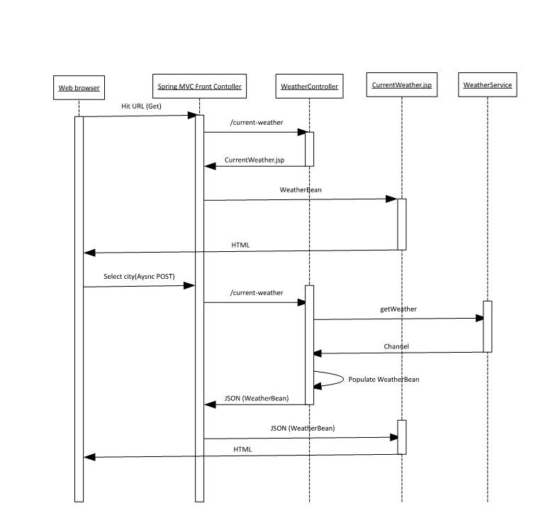

# Exception handling:

All possible checked exceptions are encapsulated as WeatherServiceException.

All exceptions are handled by a single exception handler which always returns the status code as “Internal server error” and the error message.

Error messages are defined in messages.properties file.

# Project Structure

Current-weather

/src/main/java:

com.btg.weather: Controller, service and model classes

com.btg.weather.exception: Exception class and Error codes

src/main/resources: error messages properties file

src/test/java: JUnits

src\main\webapp\WEB-INF\views: jsp page

src\main\webapp\WEB-INF: SpringConfig-servlet.xml and web.xml